Belleville Water Sports

PADDLE BOAT AND KAYAKING ACTIVITIES RELEASE OF LIABILITY, WAIVER
OF CLAIMS ASSUMPTION OF RISKS AND IDEMNITY AGREEMENT (hereinafter the
“Release Agreement”)

Read Carefully

TO: PADDLE RENTALS LLC, and their directors officer, employees, guides, agents,
independent contractors, subcontractors, volunteers, representatives, successors and assigns (all
of whom are hereinafter collectively referred to as the "Releasees")

DEFINITIONS In this Release Agreement, the term "Activity" Shall include all activities,
transportation, events and services provided, arranged, organized, conducted, sponsored or
authorized by the Releasees and shall include but is not limited to: stand- up paddle boarding,
swimming, paddle boating, kayaking, and other forms of open or closed water-based activity;
rental or use of stand-up paddle boards or other equipment; demonstrations; orientational and
instructional courses; loading, unloading of equipment including around motor vehicles; and
other activities, events and services in any way connected with or related to the Activity.
ASSUMPTION OF RISKS - STAND-UP PADDLE BOARDING, SWIMMING, PADDLE
BOATING, KAYAKING, AND OPEN OR CLOSED WATER-BASED ACTIVITY,
CURRENTS, TIDES, WEATHER ETC. I am aware that participating in the Activity in open or
closed water involves risks, dangers and hazards. Currents, tides and waves occur frequently in
open water and may be caused by natural forces or by other watercraft, such as boats and ships. I
acknowledge and accept that the Releasees may fail to predict whether the open or closed water
is safe for the Activity or whether an unexpected current, wave or weather condition may occur.
The risks and dangers of the Activity include, but are not limited to: choice of paddle boat or
kayak, changing weather , surf, tidal or ocean current conditions; impact or collision with paddle
boat(s) or other watercraft, other persons, ocean or lake bottom; slippery terrain; prolonged
exposure to cold water, solar radiation, dehydrations, hypothermia; drowning; exposure to
poisonous and/or carnivorous sea life; the failure to perform any physical activity associated with
the Activity safely or within one's own ability or within designated areas; negligence of other
persons or becoming lost or separated from one's party or guide; and NEGLIGENCE ON THE
PART OF THE RELEASEES. | UNDERSTAND THAT NEGLIGENCE INCLUDES FAILURE
ON THE PART OF THE RELEASEES TO TAKE REASONABLE STEPS TO SAFEGUARD
OR PROTECT ME FROM THE RISKS, DANGERS AND HAZARDS OF THE ACTIVITY.
The site(s) used for the Activity may be uncontrolled, unmarked, uninspected an may involve
many risks, dangers and hazards in addition to that of the Activity including but not limited to
hidden and/or submerged obstacles such as rocks, coral reefs, tree stumps, forest deadfall or
other man-made objects. I AM AWARE OF THE RISKS, DANGERS AND HAZARDS
ASSOCIATED WITH THE ACTIVITY AND I FREELY ACCEPT AND FULLY ASSUME ALL
SUCH RISKS. DANGERS AND HAZARDS AND THE POSSIBILITY OF PERSONAL
INJURY, DEATH, PROPERTY DAMAGE OR LOSSRESULTING THEREFROM. RELEASE
OF LIABILITY, WAIVER OFCLAIMS AND INDEMNITY AGREEMENT. In consideration of
THE RELEASEES allowing me to participated in the activity, I hereby agree as follows:1. TO
WAIVE ANY AND ALL CLAIMS that I have or may in the future have against THE
RELEASEES and TO RELEASE THE RELEASEES from any and all liability for any loss,
damage, expense or injury including death that | may suffer or that my next of kin may suffer as a
result of my participation in the Activity, DUE TO ANY CAUSE WHATSOEVER,
INCLUDING NEGLIGENCE, BREACH OF CONTRACT, OR BREACH OF ANY
STATUTORY OR OTHER DUTYOF CARE, INCLUDING ANY DUTY OF CARE OWED
UNDER THE OCCUPIERS LIABILITY ACT, R.S.B.C. 1996 , C. 337, ON THE PART OF THE
RELEASEES. I UNDERSTAND THAT NEGLIGENCE INCLUDES FAILURE ON THE PART
OF THE RELEASEES TO TAKE REASONABLE STEPS TO SAFEGUARD OR PROTECT
ME FROM THE RISKS, DANGERS AND HAZARDS OF THE ACTIVITY REFERRED TO
ABOVE; 2. TO HOLD HARMLESS AND INDEMNIFY THE RELEASEES from any and all
liability for any property damage or personal injury to any third party resulting from my
participation in the Activity,3. This Release Agreement shall be effective and binding upon my
heirs, next of kin, executors, administrators, assigns and representatives, in the event of my death
or incapacity;4. This Release Agreement and any rights, duties and obligations as between the
parties to this Release Agreement shall be governed by and interpreted solely in accordance with
the laws of the United States an no other jurisdiction; and 5. Any litigation involving the parties
to this Release Agreement shall be brought solely within the United States and shall be within the
exclusive jurisdiction of the Courts of the United States. 6. In entering into this Release
Agreement I am not relying on any oral or written representations or statements made by the
Releasees with respect to the safety of the Activity, other than what is set forth in this Release
Agreement.

The equipment must be returned in the same conditions as we rented them. In case of damage or
loss, you are the only responsible person for it and you will have an extra charge ($500 per
paddle boat or kayak, $20 per life jacket, $75 per hand paddle). In case you rent a waterproof
bag, you are the only responsible person in case of damage or loss of your
belongings.

The equipment must be returned on time. In other case, you will be charged $30 per every hour late.

I CONFIRM THAT I HAVE READ AND UNDERSTOOD THIS RELEASE
AGREEMENT PRIOR TO SIGNING IT, AND 1AM AWARE THAT BY SIGNING THIS
RELEASE AGREEMENT | AM WAIVING CERTAIN LEGAL RIGHTS WHICH I OR
MY HEIRS, NEXT OF KIN, EXECUTORS, ADMINISTRATORS, ASSIGNS AND
REPRESENTATIVES MAY HAYE AGAINST THE RELEASEES.

NAME:_________________________________________________ DATE:______________

PHONE NUMBER:_________________________________

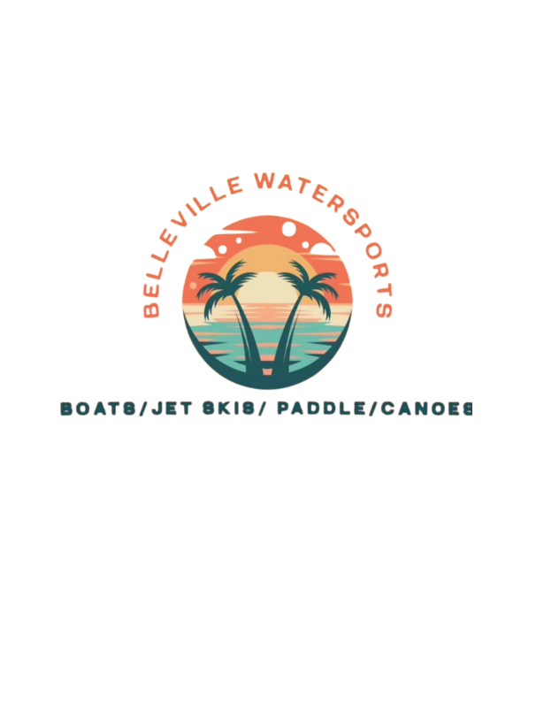
Name:______________________________________________________

Email:_______________________________________________________

Emergency Contact:_______________________________________

Signature:__________________________________________________

I acknowledge that I have read and understand all of terms and conditions of this agreement and that I am voluntarily waiving substantial legal rights (on my behalf and on the behalf of my heirs, executors, administrators, successors and assigns, including the right to sue the company and the releases). I have read this form and am signing this voluntarily.

